**World Quant University**

**Professor: Ivan Blanco**

**Alpha Design I**

Nikolas Lippmann Pareschi - [nikolaslippmann@gmail.com](mailto:nikolaslippmann@gmail.com)

**Assignment: Unit 2**

1. Write a Python program to download the historical data of Apple Inc. (AAPL) and Microsoft Corp (MSFT) for the last 3 years.

Code: 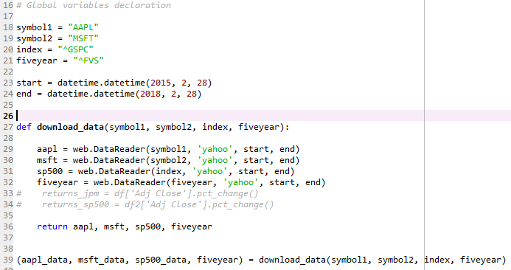

1. Calculate the daily return for AAPL and MSFT and present a comparative graphical analysis.

Code:

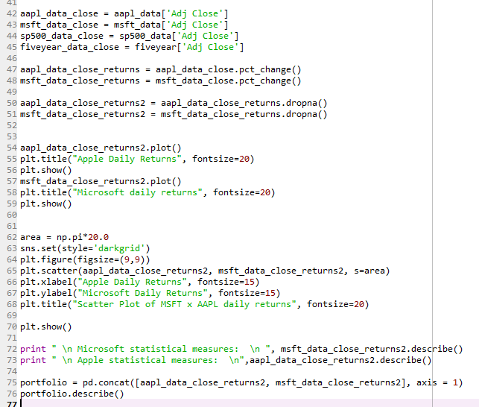

Results:

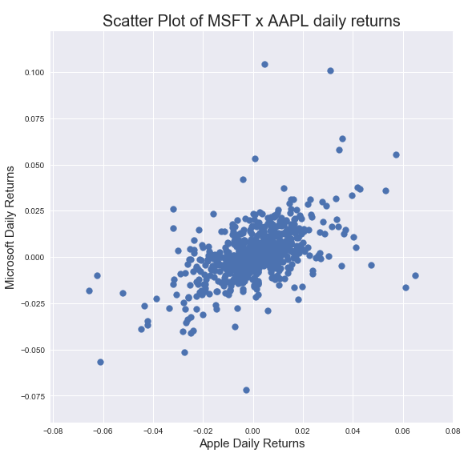

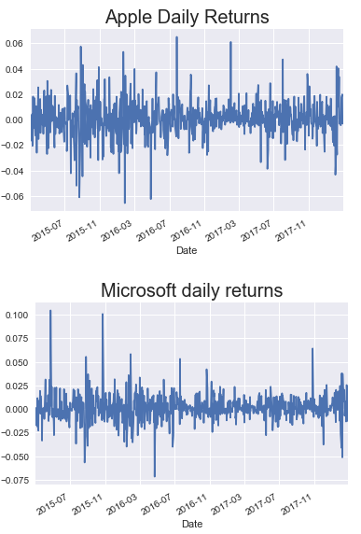

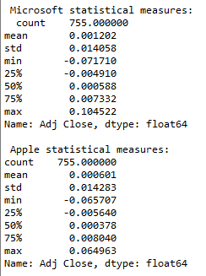

1. Calculate and graphically represent the expected return for each of the stocks. To do this, we have to calculate the average of the daily returns of the period being analyzed and then annualize

Code:

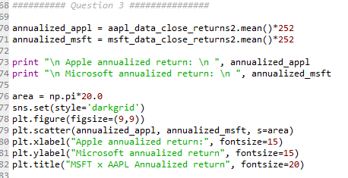

Results:

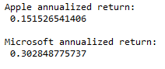

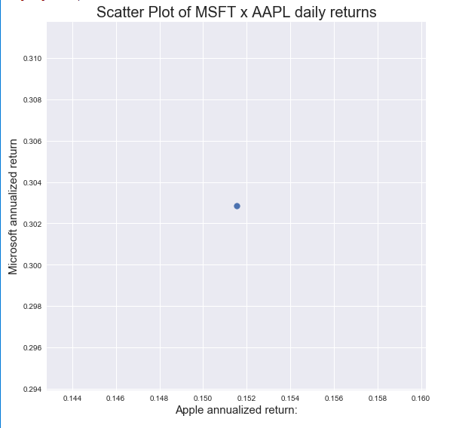

1. Calculate the Standard Deviation of the portfolio. The used stocks on the portfolio are correlated, so remember to use the appropriate Variance formula (reference the PDF for that formula if needed).

Calculated in 2 ways to double check and result_var (formula with covariance) was indeed equal to port_var:

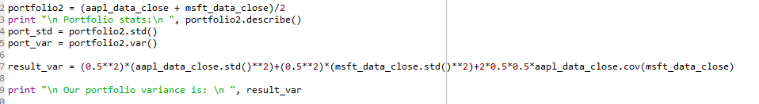



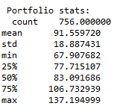

1. The United States Treasury Bonds are known as risk free because they always pay. For this analysis, a 5-year bond will be considered with an annual rate of 1.72%.  How does the return profile of the current portfolio compare to one that is consisting solely of Treasury Bonds?

If we take the mean of the returns in the period considered, the 5 years notes in fact presented negative returns. In fact, even T-Bill presented negative returns considering that the FED started to tighten in the period. As one see, the risk free rate name is indeed not so true. But the standard deviation is really lower. I ploted to graphs, one considering the real five year return and the other considering the giving 1.72%. For the second I took the standard deviation from the first, because that data was not given. Abou the returns, they are higher usually but the standard deviation is also higher.

Code:

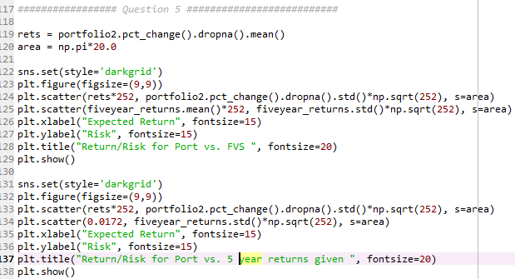

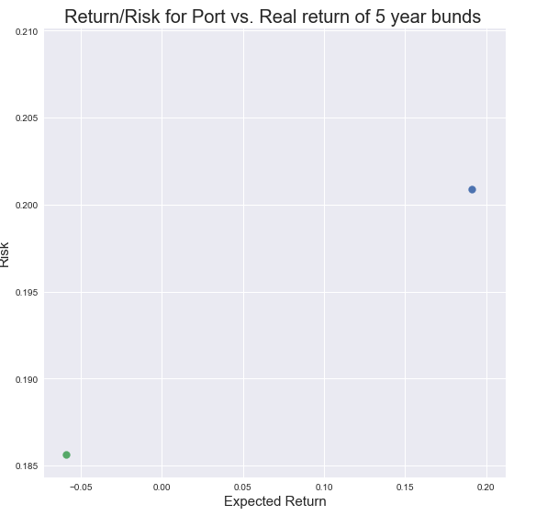

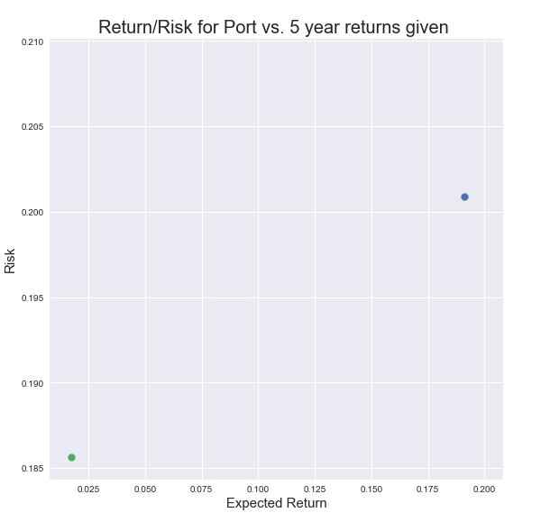

1. How does the Risk Profile of the two compare?  Use Python to print a comparative analysis of the two portfolio in terms of all the major KPIs taught in this course.

Code:

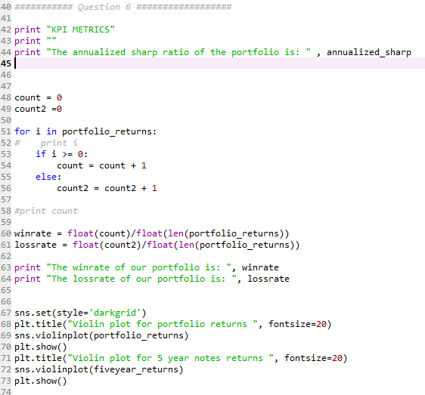

I chose the KPI metrics, sharp ratio and win and loss rate to proceed with the analysis. The sharp ratio of the 5 years will be zero, if we consider it as the risk free rate. The sharp ratio of the portfolio is:

